Варіант 2. Завдання 3

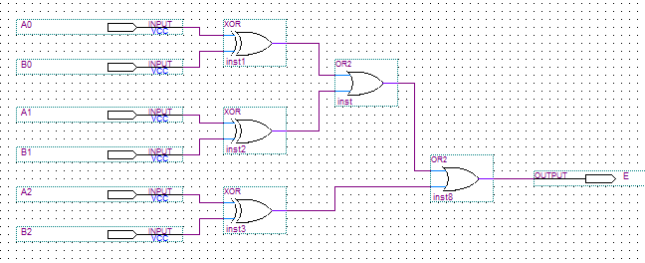

Варіант 3. Завдання 3

|  |  |  |  |  |
| --- | --- | --- | --- | --- |
| X1 | X2 | X3 | X4 | Y |
| 0 | 0 | 0 | 0 | 0 |
| 0 | 0 | 0 | 1 | 0 |
| 0 | 0 | 1 | 0 | 0 |
| 0 | 0 | 1 | 1 | 0 |
| 0 | 1 | 0 | 0 | 0 |
| 0 | 1 | 0 | 1 | 0 |
| 0 | 1 | 1 | 0 | 0 |
| 0 | 1 | 1 | 1 | 1 |
| 1 | 0 | 0 | 0 | 0 |
| 1 | 0 | 0 | 1 | 0 |
| 1 | 0 | 1 | 0 | 0 |
| 1 | 0 | 1 | 1 | 1 |
| 1 | 1 | 0 | 0 | 0 |
| 1 | 1 | 0 | 1 | 1 |
| 1 | 1 | 1 | 0 | 1 |
| 1 | 1 | 1 | 1 | 1 |

